# 



Immersion Day

S3 Hands-On Lab

Getting Started with Simple Storage Service

# Amazon S3 Overview

Amazon Simple Storage Service (S3) provides a simple web services interface that can be used to store and retrieve any amount of data, at any time, from anywhere on the web. This lab is designed to demonstrate how to interact with S3 to store, view, move and delete objects.

This lab will walk you through the following:

* Creating a bucket in S3
* Adding an object to the S3 bucket
* Creating a Lifecycle Policy to move objects to Glacier Archive
* Deleting the Objects and the Bucket

# Lab Objective

Create a lifecycle policy that moves objects to Glacier Archive if they haven't been accessed in the last 30 days. Additionally, create a lifecycle policy that moves the previous version of an object to Glacier Deep Archive if not accessed within the last 10 days.

# Create a Bucket in S3

To upload your data (photos, videos, documents etc.) to Amazon S3, you must first create an S3 bucket in one of the AWS Regions. You can then upload your data objects to the bucket. Every object you store in Amazon S3 resides in a bucket. You can use buckets to group related objects in the same way that you use a directory to group files in a file system.

***Note:*** *You are not charged for creating a bucket; you are only charged for storing objects in the bucket and for transferring objects in and out of the bucket.*

***Note:*** Transfer IN does not incur a charge, but Transfer OUT does. Data transfers are free if you are within the same region and within the same availability zone, and use a private IP address. Data transfers to other regions or services will have a cost associated with them. See <https://aws.amazon.com/s3/pricing/> for more details.

1. Sign into the AWS Management Console and open the Amazon S3 console at <https://console.aws.amazon.com/s3>.
2. 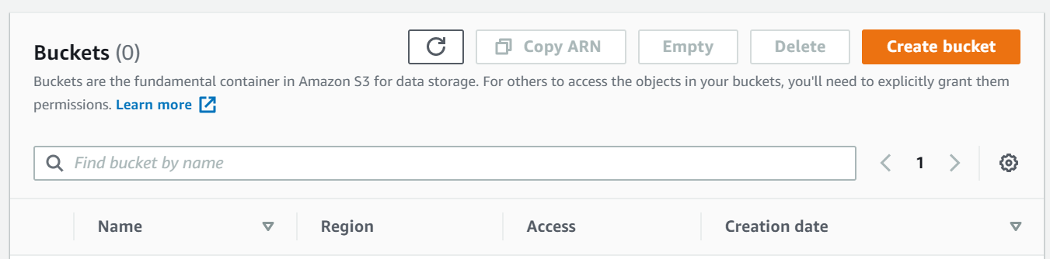Click **Create Bucket**. The **Create a Bucket** wizard will open.

**Note:** Enter a bucket name in the Bucket Name field. Since S3 is a global service, the bucket name you choose must be unique across all existing bucket names in Amazon S3. One way to do that is to prefix your bucket names with your organization's name.

Bucket names must comply with the following requirements. The bucket name:

* Must be unique across all of Amazon S3
* Must be between 3 and 63 characters long
* Must not contain uppercase characters
* Can contain only lower-case characters, numbers, periods, and dashes
* Must Start with a lowercase letter or number
* Must not contain underscores, end with a dash, have consecutive periods, or use dashes adjacent to periods.
* Cannot be formatted as an IP address ([198.51.100.24](http://198.51.100.24/)).

**Note:** There might be additional restrictions on bucket names based on the region your bucket is in or how you intend to access the object. Once you create a bucket, you cannot change its name. In addition, the bucket name is visible in the URL that points to the objects stored in the bucket. Make sure the bucket name you choose is appropriate.

1. In the **Region** drop-down list box, select a region. Choose a Region close to you to minimize latency and costs and address regulatory requirements. Objects stored in a Region never leave that Region unless you explicitly transfer them to another Region

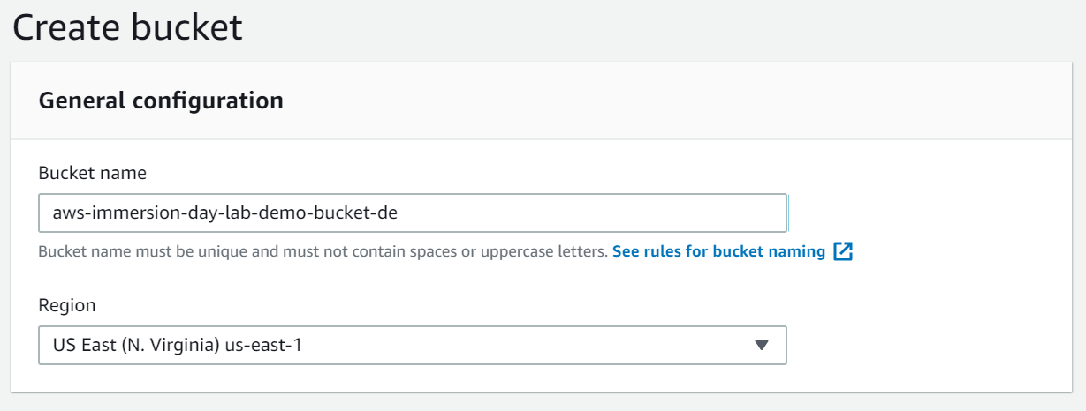

1. By default, all buckets are set to “block public access”. For this particular scenario, we would unblock all public access. **Uncheck** the Block all public access and **acknowledge** the settings

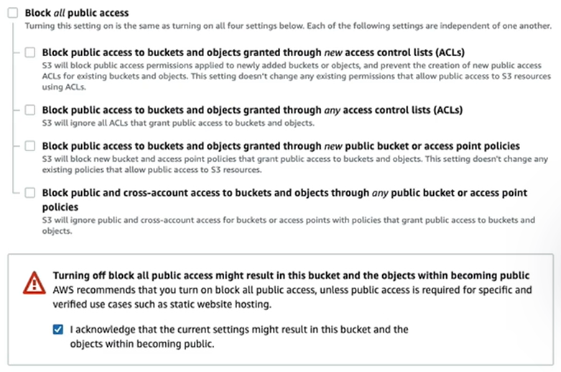

1. Scroll to the bottom of the page and click Create Bucket to create your bucket.

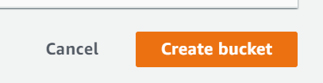

1. Once your bucket is created, you will be able to see it in your Buckets list. You can also see the region your bucket is in along with the access type.

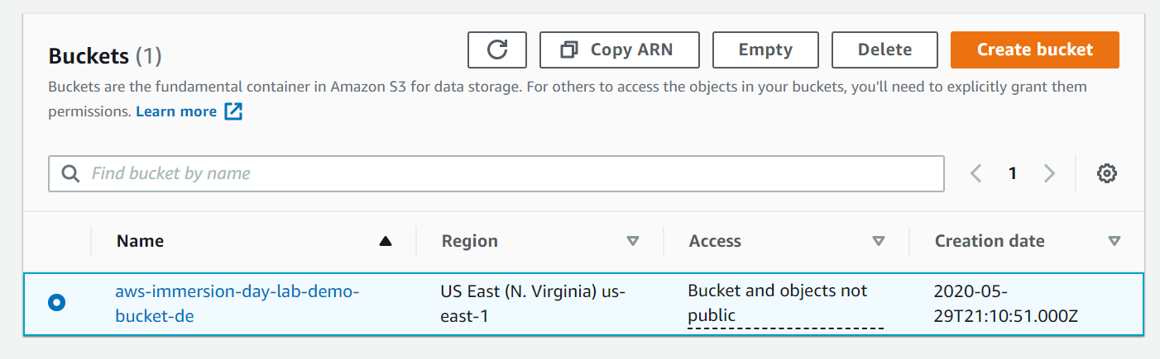

**Well done – you have created your bucket in Amazon S3!**

# Add an Object to a Bucket

Now that you have created a bucket, you are ready to add an object to it. An object can be any kind of file: a text file, a photo, a video and so forth. When you upload a file to Amazon S3, it is stored as an S3 object. Objects consist of the file data and metadata that describes the object. You can have an unlimited number of objects in a bucket. [Learn More](https://docs.aws.amazon.com/AmazonS3/latest/user-guide/upload-objects.html)

1. In the Amazon S3 console, click the on the name of the bucket that you want to upload your folders or files to. This should be the bucket you just created.
2. Choose Upload.

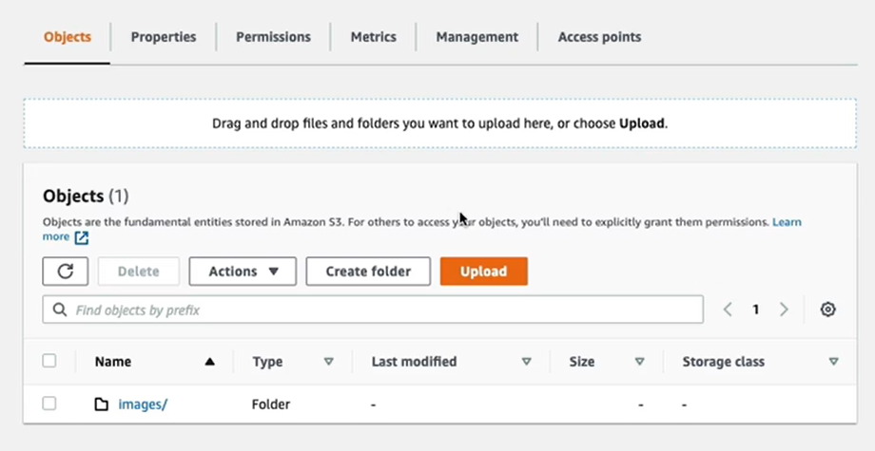

1. In the Upload Dialog box, choose Add Folder

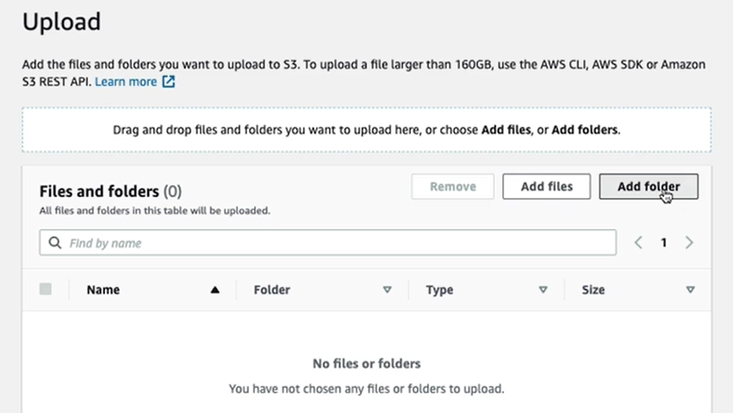

1. Choose a folder from your computer to add. For this lab, you can choose a folder that has sample pictures on your laptop. Click **Upload three times** to complete the upload

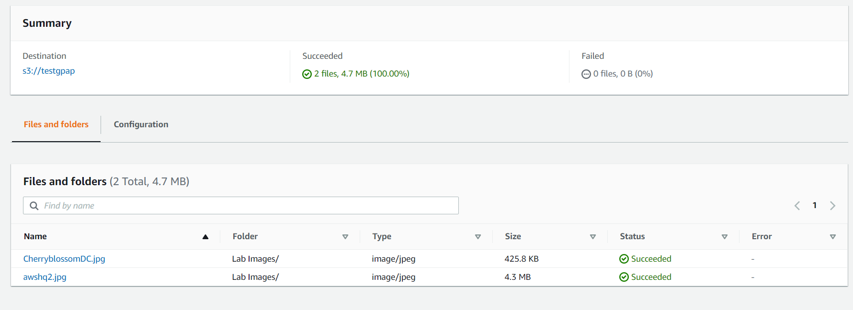

**Good work - you have added file(s) to your bucket!**

# Create a S3 lifecycle rule

1. In the Amazon S3 console, click on the link representing the bucket that you created
2. Click on the **Management** tab and then click Create lifecycle rule

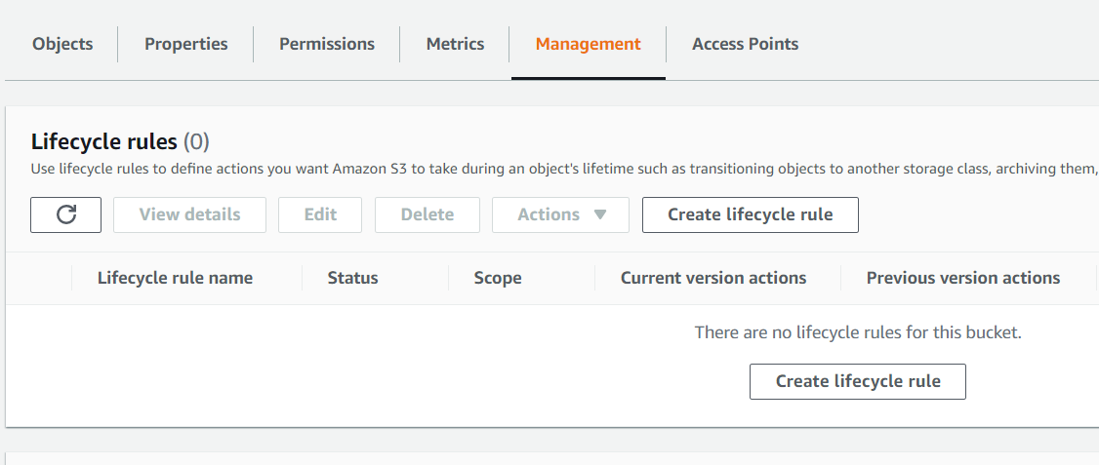

1. Type a **name** for the rule
2. Rule scope: For this lab, choose Limit the scope of this rule using one or more filters. In the Prefix, type Lab2 since the sample data contains the “Lab2” prefix. This particular rule will pick up files that have the *lab2* prefix

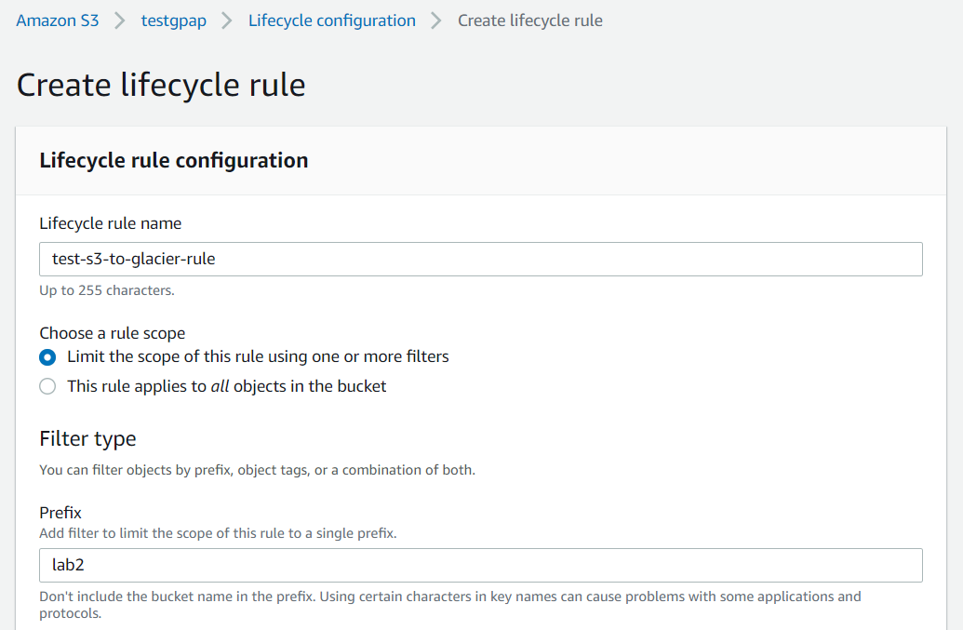

1. Within the Lifecycle rule actions, check the first two boxes

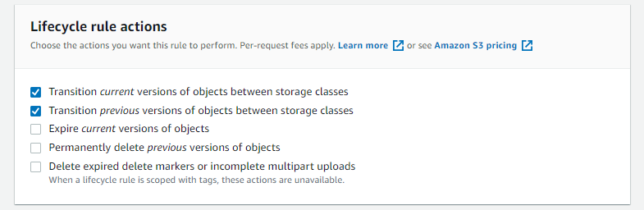

1. For the first option, *Transition current versions of objects between storage classes*, select Glacier from the dropdown menu and type 30 in the Days field. Check the box for acknowledgement

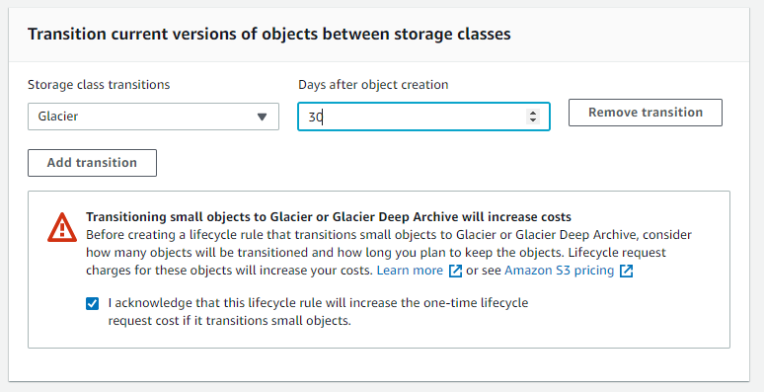

1. For the second option, *Transition noncurrent versions of objects between storage classes,* select Glacier Deep Archive from the dropdown menu and type 10 in the Days field. Check the box for acknowledgement

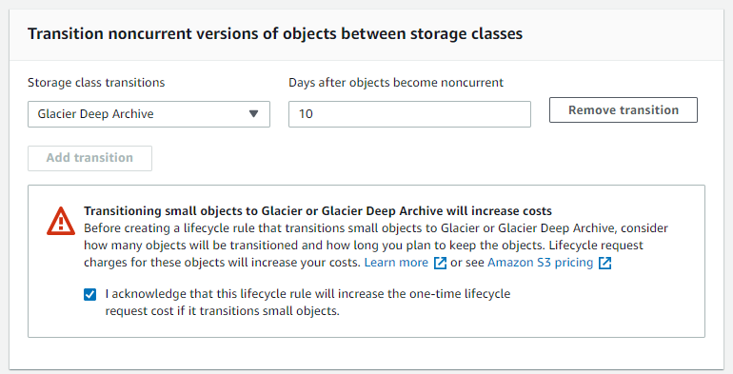

1. Click Create rule at the bottom of the page



**Good work - you have created the S3 lifecycle rule!**

# Delete an Object and Bucket

You have added an object to a bucket and create a lifecycle rule. Now, you can delete it and the bucket it is in. If you no longer need to store the objects you uploaded and moved while going through this guide, you should delete them so you do not incur further charges on those objects.

1. In the Amazon S3 console, click on the link representing the bucket containing the object(s) you want to delete. Then select the checkboxes for the object(s) you would like to delete.
2. Click the **Actions** button. Then select **Delete**. To confirm the action in the **Delete objects** dialogue, click **Delete**.

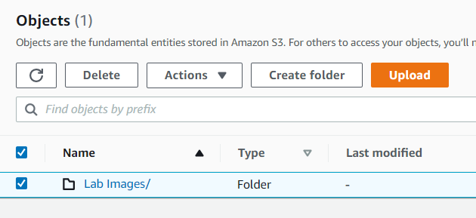

1. Confirm the deletion by typing *permanently delete* in the text input field and click Delete objects

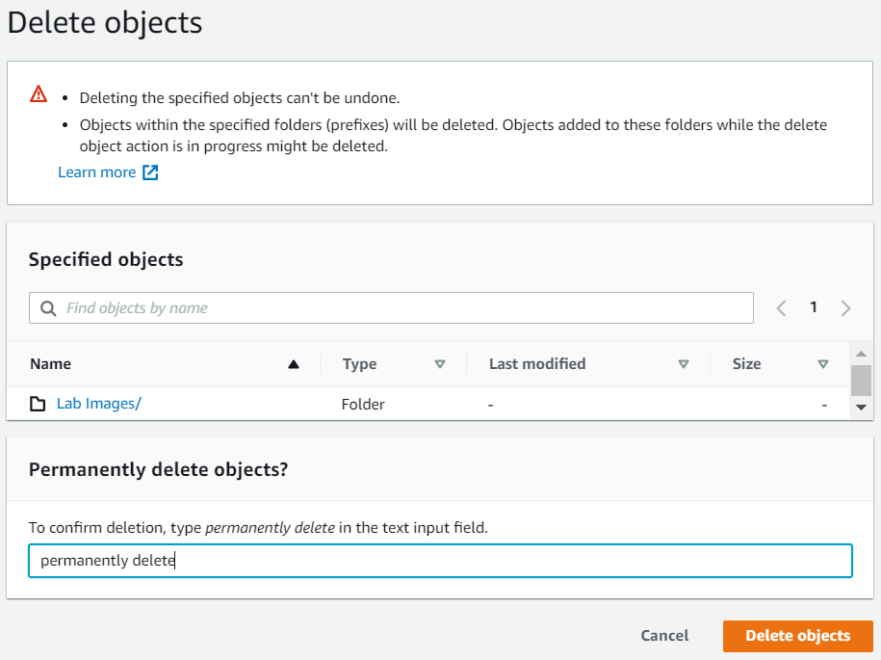

1. 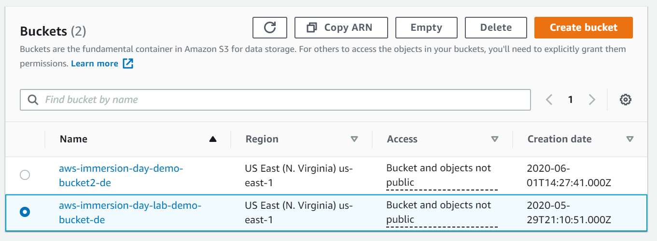Navigate back to the S3 console and select the bucket icon of the bucket you want to delete (not the link to its right), and at the top of the page, click **Delete**. Confirm the deletion by typing its name verbatim at the **Delete bucket** prompt.

**Well done, your bucket is now deleted!**

# Conclusion

In this lab you have learned the basic operations to manage the lifecycle of an S3 object. First, you created a bucket, which is the logical container of objects. Then by uploading, and creating lifecycle rule, you learned the basic operations of the object itself. Most organizations have tons of data and lot of times that data is not accessed on a regular basis. By moving that data to a Glacier and Glacier Deep archive, organizations can save on their S3 storage costs. Finally, you learned how to delete both an object and a bucket.

You can also access S3 from the AWS CLI or the API

[Click here for CLI Information](https://docs.aws.amazon.com/cli/latest/userguide/cli-services-s3.html)

[Click here for API information](https://docs.aws.amazon.com/AmazonS3/latest/API/Welcome.html)

You should continue exploring more features of S3!

* Did you know you can host a website entirely on S3?
* Did you know you can automate restore of files from Glacier?
* How about fine-grained access control with Bucket Policy?